Chapter 3 City Jail Assignment 1(70 marks)

Create all the tables for the database as given in the following data dictionary, Section A. Make the modifications outlined in Section B. Save all the SQL statements used to accomplish these tasks. Also take the screen shots of commands to create tables and paste them under each corresponding table object.

Section A (61 marks)

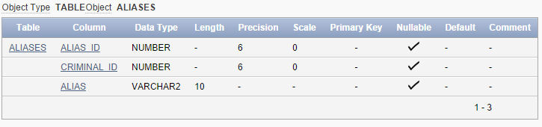

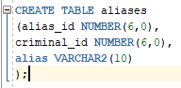

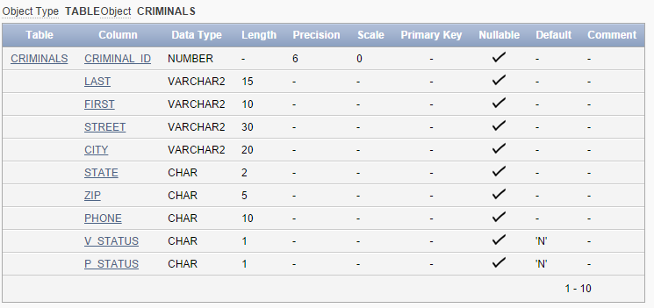

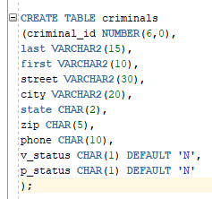

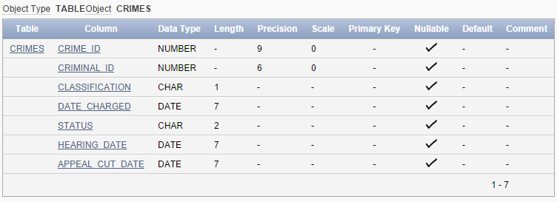

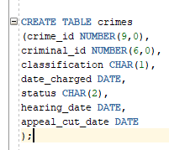

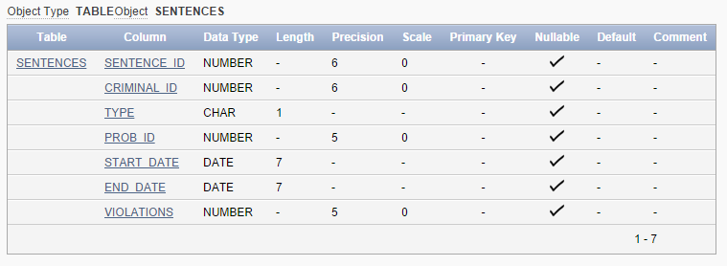

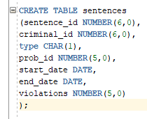

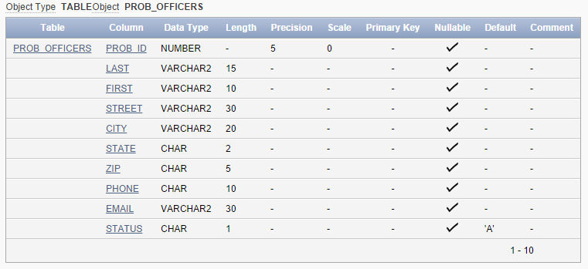

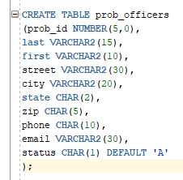

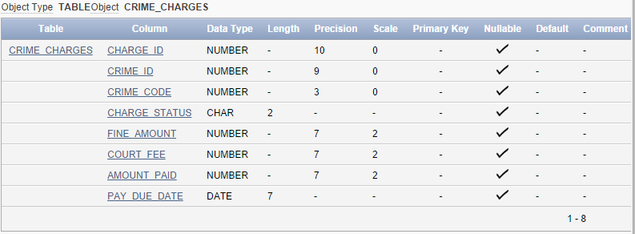

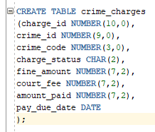

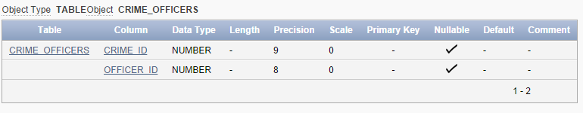

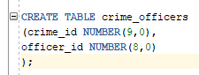

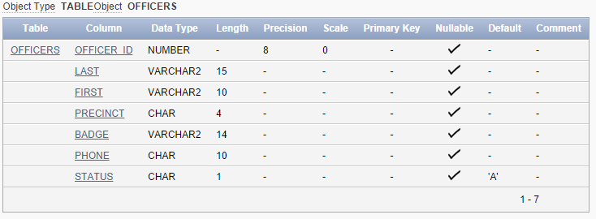

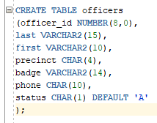

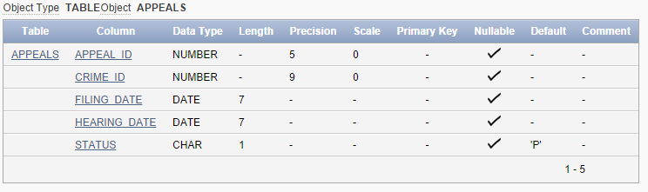

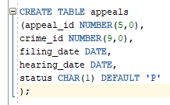

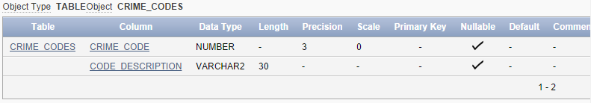

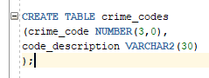

SECTION B (9 marks)

Add a default value of U for the classification column of the Crimes table as shown below. (2 marks)

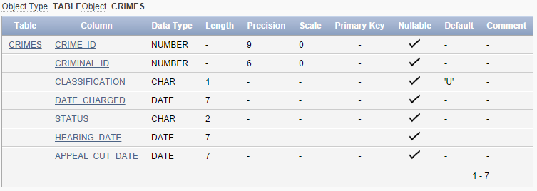



Add a column named Date_Recorded to the crimes table. This column needs to hold date values and should be set to the current date by default as shown below: (3 marks)

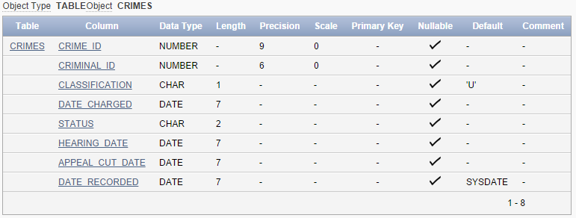

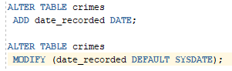

Add a column to the Prob_Officers table to contain the page number for each officer. The column needs to accommodate a phone number, including area code. Name the column Pager# as shown below. (2 marks)

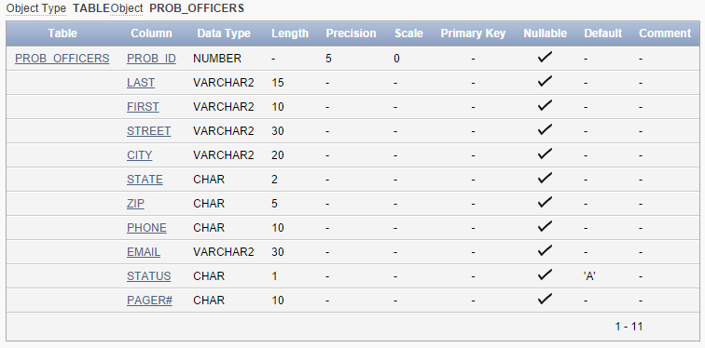



Change the Alias column in the Aliases table to accommodate up to 20 characters as shown below: (2 marks)

